Signal & Data Analysis in Neuroscience
Bar Ilan, Spring 2018 Due: May 7 8:00 AM.

Assignment 06 PCA
1) PCA Matlab question
The data file ‘dataPCA.mat’ contains a matrix called ‘lfp’. Each row of the matrix represents LFP recording of one trial, using a sampling rate of 4KHz.
Calculate the PCA of the LFP (using your own algorithm, not matlab’s built-in PCA functions):
a) Plot the first 2 principal components.
b) Plot histograms of the projections of each trial onto each of the chosen components.
Also plot a scatter-plot of the projections on the 2 components plain. Explain the graphs referring to classification and representation of the data.
c) What is the percentage of the variance of the data that is explained by the 1st component? By the 2nd component? By both components combined?
What is the percentage of the variance that remains unexplained by the 2 components?
d) Find the vector (dimension) with the highest variance before PCA, and calculate its entropy. Calculate the entropy of data on the first eigen vector. Explain your results.

2) PCA Exam 2010
The MEG signal recorded by two Squids (SA & SB) is distributed Normally N(μ=0,σ=1). During three experiments the following covariance matrices were calculated
(all higher moments are 0):
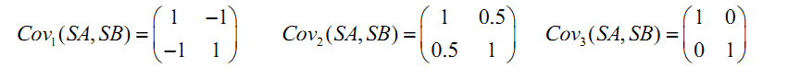
a) Sketch sample values of SA vs. SB for the three experiments (demonstrating the joint distribution).
b) Estimate the eigenvalues and eigenvectors for the three experiments.
c) In which experiment do the sensors display the highest redundancy and in which one the lowest? Explain.

